GGL System report

(<http://ggl.neotural.com/login>)

1. Admin – Approval booking – Please for information Approval Booking adjusted by information booking details (sort by category)

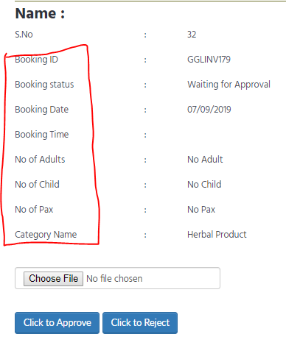

2. [www.gglway.com](http://www.gglway.com) – Contact – Please add for receive an any Message in GGL to email : globalgains49@gmail.com - cannot click send

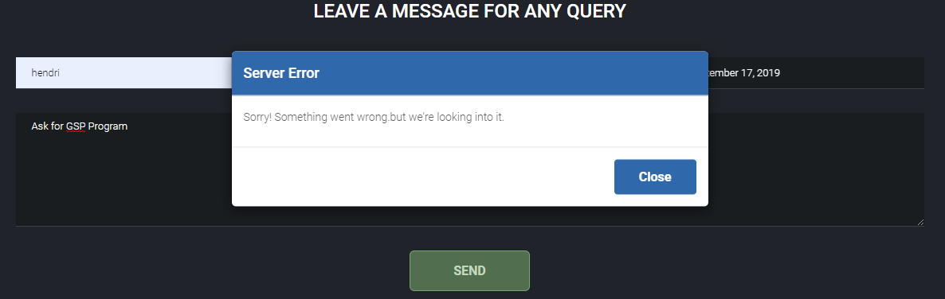

3. Member – Email – Not get email notification if Unit Status is Close - Please add for member and admin (admin must know if Status is Close)

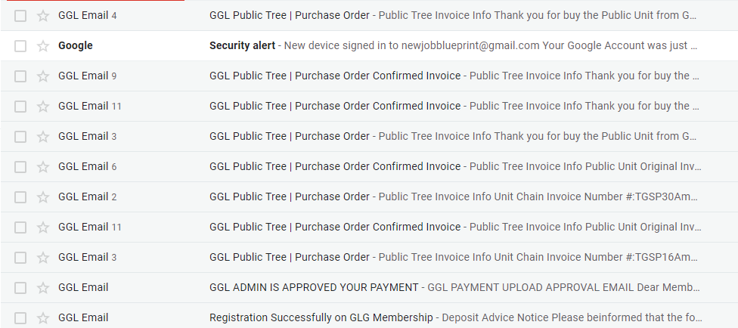

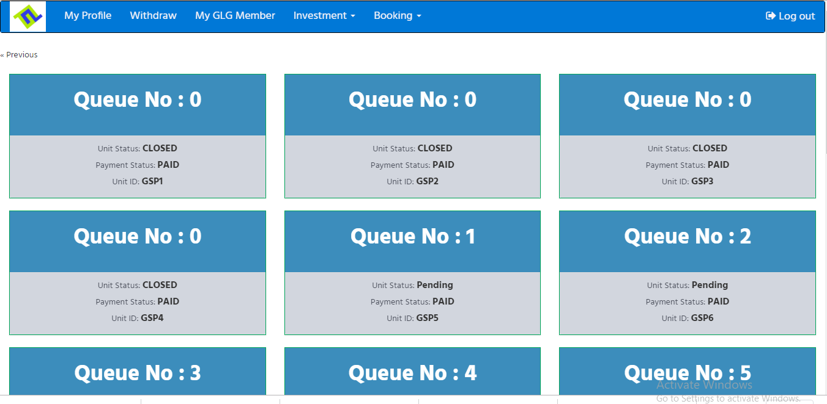

3. Email - Member – Investment – Purchase Unit – Notification Invoice on email (please change like this picture)

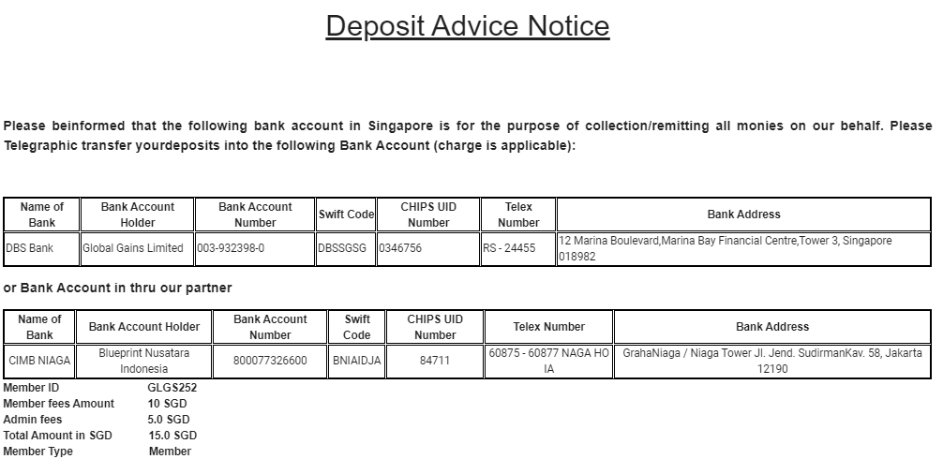

GGL Mobile Apps report

1. Member – Withdrawl – Cannot Click Withdrawl

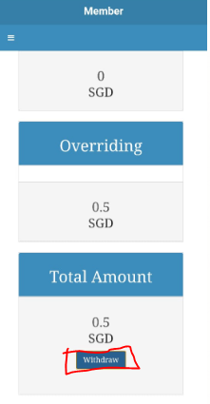

2. Member – Investment – Payment Option – Online Payment – Cannot Continue to Checkout

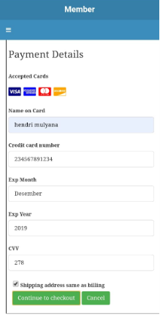

3. Member – Investment – Payment Option – Wire Payment – Please for bank account details entered into the wire transfer column ( Change Name Account Holder to Blueprint Nusantara Indonesia)

